Known things to fix
These are things that needs to be updated:

- When user enters their narrative, try to automatically fill in the context, evidence, and question based upon what the user entered for the narrative. The user should also be able to edit what has been filled in.
- New Analysis doesn’t work after entering Narrative. Make sure every feature and button works.
- Relationship Status doesn’t work when trying to select it
- Make sure evidence locker works and is safe for users to upload their evidence. Make sure that info is encrypted and can’t be hacked.
- Save each report/session user does
- Pre-fill core questions based up the narrative and leave space for user to add more questions if needed
- When a report is given, there should be an option for the user to download the PDF version of the report (Premium feature that costs $15/month) as well as an option to share the report with anybody through whatsapp, text, email etc (Also included in premium feature).
- Also included in premium feature: The connection of partner app and the indepth insights given for both partners as well as the suggested activities.
- Under profile, there should be an option for user to take the MBTI personality test, as well as what their zodiac star sign is based upon their birthday. They should also be able to take the enneagram test on the app. These should be premium features as well as this will also tell me alot about their communication style as well as their partner’s.
- Once a report is generated, at the bottom of the report these should be options for the user to take:
  - Add To Today’s Journal?
  - Link Partner Connection? (Invite’s Partner to view the report - premium feature)
  - Create custom action plan? (User AI to create Action Plan/Micro-exercises - premium feature)
  - Create custom Weekly Challenges to improve relationship? (Use AI to create weekly challenges in order to improve relationship - premium feature)
  - Create Custom Exercises for you and you partner? (Use AI to create custom exercises to help the relationship - premium feature)
  - Create Custom Quizzes? (With the help/suggestion of AI, create a quiz to ask partner. And should be able to send the questions directly to partner once the quiz is created)
  - Create a vision of what you would ideally like this relationship to look like (AI asks questions about what the ideal relationship in this scenario would look like and what can be done to achieve this etc)
  - Cooldown button doesn’t work
  - Notes section (any notes about this session that user would like to write down as well as a prompt if user would like to add these notes to journal)

Application UI/UX Audit & Refactoring Guide: Aura

Application UI/UX Audit & Refactoring Guide: Aura
A comprehensive analysis of the Aura application reveals opportunities to refine the interface for beta testing. To ensure the platform aligns with modern, minimalist design aesthetics and follows a problem-first engineering philosophy, the following AI-friendly report details actionable improvements. The structure is optimized to be fed directly into an AI coding assistant (such as Cursor, Copilot, or standard LLMs) for immediate implementation.

Context for AI Agent
- Application Context: Aura is an AI-powered relationship intelligence platform. The interface requires a trustworthy, secure, and empathetic tone.
- Design Language: Modern, minimalist, clean typography, and a cohesive dark-mode color palette.
- Objective: Refactor current UI components to reduce cognitive load, improve WCAG accessibility standards, and streamline user flows for a production-ready beta launch.

1. Global Navigation & Information Architecture
Current State: The Home dashboard features a horizontally scrolling top navigation bar containing over ten distinct modules (Journal, Partner, Health Report, Challenges, Exercises, Quizzes, Mood Map, Cool Down, Vision, Health, Archive). This creates cognitive overload and violates Miller’s Law regarding working memory.
Required Refactor: Consolidate the navigation hierarchy.
- Action: Deprecate the top-scrolling pill navigation on the Home screen.
- Action: Map these standalone features as nested routes within the primary Bottom Navigation architecture.
  - Move Exercises, Challenges, and Quizzes into the Growth tab.
  - Move Mood Map, Health Report, and Archive into the Journal or a new dedicated Insights tab.
  - Move Partner Settings and Vision Board into the Profile tab.
AI Implementation Prompt:
"Refactor the navigation architecture. Remove the horizontally scrolling top navigation component (TopNavPills) from the Home screen. Create a nested routing structure where 'Exercises', 'Challenges', and 'Quizzes' are accessible via tabbed or card-based navigation within the Growth screen. Ensure the Bottom Navigation remains the primary anchor for routing."

2. Accessibility & Color Contrast
Current State: The dark theme relies heavily on deep navy/black backgrounds with muted purple or gray secondary text. Certain inactive elements and timestamp texts fall below the WCAG AA contrast ratio threshold of 4.5:1.
Required Refactor: Optimize the dark mode color palette for legibility.
- Action: Increase the luminance of secondary text elements (text-gray-500 or equivalent) to a lighter shade (e.g., #A3A3A3 or #9CA3AF).
- Action: Ensure button disabled states and unselected navigation icons have sufficient contrast against the deep background.
AI Implementation Prompt:
"Audit the dark mode color palette within the Tailwind/CSS configuration. Update all instances of secondary text to ensure a minimum contrast ratio of 4.5:1 against the background (#0F111A or similar). Introduce a semantic color variable --text-secondary with a hex value of #9CA3AF. Apply this to timestamps, unselected tab icons, and subheadings."

3. Empty States & User Onboarding
Current State: Screens such as Vision Board, Mood Map, and Quizzes display basic, unstyled text indicating an empty state (e.g., "No quizzes yet"). This leads to a stark user experience and lacks clear direction.
Required Refactor: Standardize a reusable EmptyState component.
- Action: Design an EmptyState component that accepts an SVG illustration, a title, a brief empathetic description, and a primary Call to Action (CTA) button.
- Action: Implement this component across all empty data views to guide interaction.
AI Implementation Prompt:
"Create a reusable EmptyState React/Flutter component. It should accept props for icon (SVG), title (string), description (string), and primaryAction (function/button label). Replace the current text-only empty states on the 'Vision Board', 'Quizzes', and 'Partner Connection' screens with this new component, ensuring the layout is centered with flexbox and includes a high-contrast primary CTA button."

4. Input Forms & Interaction Design
Current State: The "New Reflection" multi-step flow features text areas and form inputs that stretch across the entire viewport width, which can be visually overwhelming. Touch targets on some checkboxes and radio buttons are minimal.
Required Refactor: Optimize form ergonomics for mobile and desktop viewing.
- Action: Introduce a maximum width (max-w-2xl) for form containers to keep text lines at a readable length (50-75 characters).
- Action: Increase touch target sizes for all interactive elements to a minimum of 44x44px per Apple Human Interface Guidelines.
- Action: Add subtle focus states (e.g., a glowing border or background color shift) to text inputs to clearly indicate active states.
AI Implementation Prompt:
"Refactor the New Reflection onboarding flow. Wrap the form elements in a container with a maximum width (max-w-2xl or equivalent) and center it horizontally. Update all text inputs and text areas to include a focus state ring (e.g., focus:ring-2 focus:ring-purple-500). Ensure all clickable areas, including radio buttons and checkboxes in the 'Primary Challenges' view, have a minimum touch target size of 44x44 pixels with appropriate padding."

5. UI Component Standardization
Current State: Dashboard cards (like "Reflections", "Milestones", "Exercises Done") lack consistent elevation or distinct visual hierarchy.
Required Refactor: Implement a unified card design system.
- Action: Standardize border radius (rounded-xl or 16px) across all dashboard cards.
- Action: Introduce a subtle border (border-white/10) or a soft inner shadow to separate cards from the background canvas without relying purely on background color differences.
AI Implementation Prompt:
"Create a standardized DashboardCard component. Apply a consistent border radius of 16px, a background color slightly lighter than the main canvas (e.g., bg-white/5), and a subtle 1px border (border-white/10). Update the Home screen metrics (Reflections, Milestones, Exercises Done) to use this unified component."

V2 Updates
Here’s version 2 updates:

- Integrate AI-driven features to facilitate direct communication between partners within the app (In premium feature). This includes: 1. Enabling partners to send messages directly to each other after a report is shared (premium feature). 2. Allowing partners to collaboratively create action plans or challenges together. 3. Implementing a shared 'Vision Board' feature where partners can contribute their ideal relationship vision. Ask user if they would like to Introduce gamification elements (inlcuded with premium feature, has on/off toggle) to encourage user engagement with relationship-building activities. This includes: 1. Awarding points or badges for completing challenges, exercises, or journal entries. 2. Implementing streaks for consistent daily/weekly usage. 3. Creating leaderboards (optional, with privacy controls) for engagement metrics like completed challenges or positive journal entries. Ask the user if they would like to Deepen the AI analysis provided in reports by: 1. Adding a 'Communication Style Compatibility' section based on MBTI, Enneagram, and Zodiac data. 2. Generating more in-depth 'Suggested Activities' tailored to the couple's specific challenges and goals. 3. Providing a 'Red Flag Analysis' with potential mitigation strategies based on user-inputted narrative and evidence.
- Add a page where user can upgrade to premium version. Include all the features that comes with premium. Premium is $15/month.
- There should be a relationship manager for different relationships/partners/friends etc where user can switch between which relationship they’re currently working on
- There should be a section where user can request for an outside friend to add more information about the user or relationship (like a best friend or someone trusted)
- Profile and Home should be under Hamburger menu
- Add a section under profile where user can send in suggestions to improve the app or features they would like to see in upcoming updates
- Add motherly advice as well in the report after the fatherly advice given. The motherly advice should be of a mature woman who has been married from a young age and has never been divorced. She should have kids who are all grown up (3 boys and 1 girl) and is doing well for herself. It should sound nurturing, but biblically strong advice.
- The user should be able to select if they would like Fatherly advice, Motherly advice, or both.

V3 Updates
Update the app with the following:

- Under Context, Primary Challenges, there should be another box that says “Other” and when checked the user can enter custom text will ai will analyze when they submit
- For “Whose Advice Would you like”, the “Both” option should be a premium only option.
- When crafting a report, the report should be a quick summary. If the user wants a full report it should be included in premium version
- Relationship report does not work ( See screenshot)
- When user logs in at least once, the user needs to stay logged in even if they leave the app for at least 30minutes. After the 30minutes, aura should log the user out automatically.
- Add “Single” and “Never Been In A Relationship” under Relationship Status.
- Under Primary Challenges add “Other” with a section to input text from user.
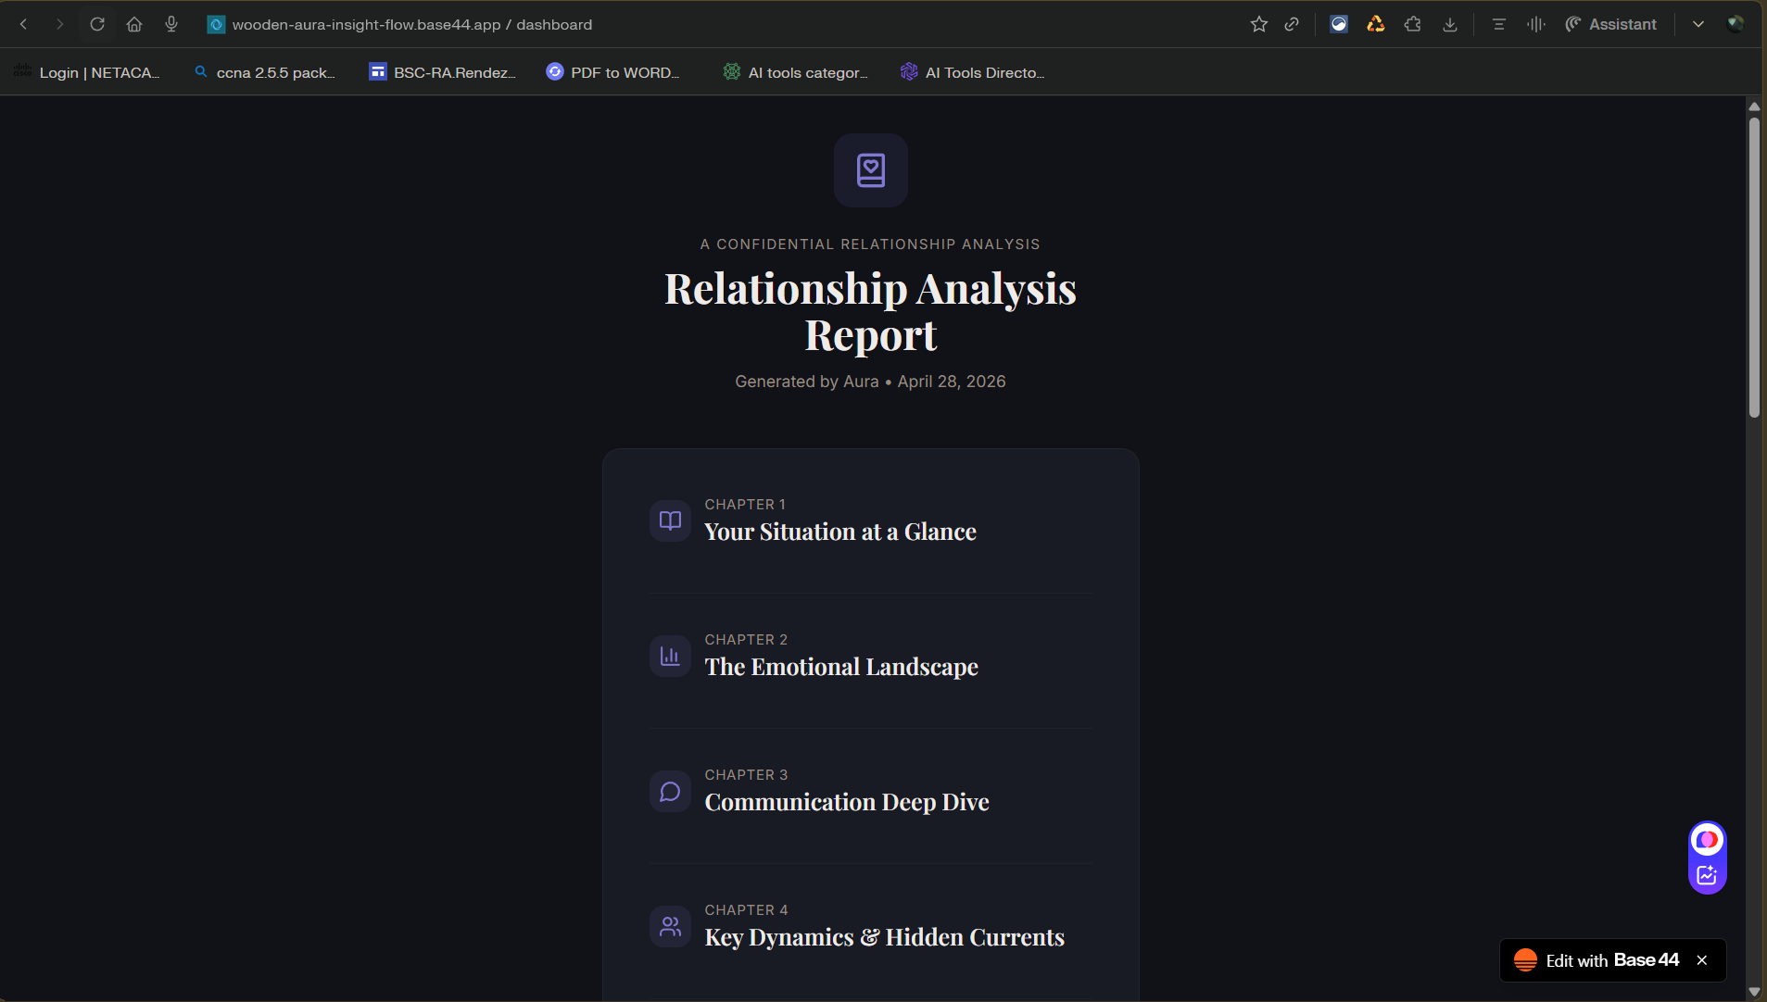

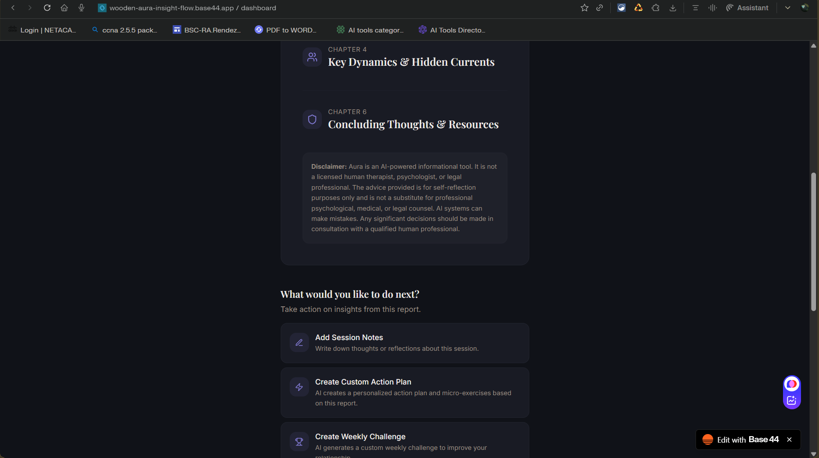

Future Advice Types: Updates
Future updates should include:
- Entrepreneur: Advice for entrepreneurs who are just getting started. The advice should come from an experienced, successful, multi-billionaire who has successfully built and ran multiple complex businesses in various sectors and is now retired. This individual should now be mentoring people and helping people build business from Ideation to their first revenue streams, to scaling to multi-millionaire business.
- Teacher: Should teacher advice who helps students study for tests and exams. The teacher should be experienced. The teacher will learn the user’s learning style and cater the learning advice according to their comprehension and learning style
- Career Advice:
- Legal Advice:
- Health Advice:

Aura Future Advice Types
Google Docs-ready version
Future updates should include:
· Entrepreneur: Advice for entrepreneurs who are just getting started. The advice should come from an experienced, successful, multi-millionaire who has successfully built and run multiple complex businesses in various sectors and is now retired. This individual should now be mentoring people and helping people build businesses from ideation to their first revenue streams, then to scaling multi-million-dollar businesses. [cite:22]
· Teacher: Should teach advice that helps students study for tests and exams. The teacher should be experienced. The teacher will learn the user’s learning style and tailor the learning advice according to their comprehension level, pace, and preferred study style. [cite:22]
· Career Advice: Should help users navigate job choices, career transitions, promotions, layoffs, workplace politics, salary negotiations, resume improvements, interview preparation, and long-term career planning. It should adapt to whether the user is a student, early-career professional, mid-career professional, executive, or someone starting over. [cite:22]
· Legal Advice: Should help users better understand common legal situations, documents, risks, and next steps in plain language. It can help with contracts, landlord-tenant issues, small claims, employment issues, business formation, intellectual property basics, consumer rights, and legal document preparation support, while making clear when a licensed attorney is needed. [cite:22]
· Health Advice: Should provide practical, easy-to-understand wellness guidance for everyday health concerns, lifestyle improvements, nutrition, sleep, fitness, stress, and prevention. It should help users understand symptoms, healthy habits, and possible next steps, while clearly encouraging professional medical care for emergencies, diagnoses, prescriptions, and serious conditions. [cite:22]
· Relationship Advice: Should help users with dating, communication, trust, boundaries, conflict resolution, emotional compatibility, breakups, reconciliation, marriage concerns, and family relationship dynamics. It should understand both emotional nuance and practical next steps.
· Mental Wellness Advice: Should help users manage stress, burnout, anxiety, overthinking, confidence issues, loneliness, motivation, emotional regulation, and life pressure in a supportive way. It should offer grounded coping strategies, reflection prompts, and habit-based improvement while clearly distinguishing coaching from therapy or crisis care.
· Financial Advice: Should help users budget, save money, reduce debt, improve credit, plan for emergencies, invest carefully, compare financial choices, and set financial goals. It should also help users understand taxes, side income, and basic wealth-building strategies in language that is easy to follow.
· Parenting Advice: Should help parents navigate discipline, communication, routines, child development, school concerns, co-parenting, and emotional support for children at different ages. It should be practical, calm, and age-aware.
· Life Coaching: Should help users make decisions, set goals, stay accountable, build confidence, improve habits, and create structure in their lives. This would be useful for people who feel stuck, overwhelmed, or unsure about what to do next.
· Spiritual Advice: Should help users explore faith, purpose, meaning, prayer, discipline, doubt, moral questions, and personal growth through a spiritual lens. It could be personalized based on the user’s beliefs or values.
· Productivity Advice: Should help users manage time, reduce procrastination, build routines, improve focus, organize tasks, and finish what they start.
· Business Strategy Advice: Should help business owners with positioning, pricing, offers, customer acquisition, branding, operations, partnerships, retention, and growth strategy.
· Startup Fundraising Advice: Should help founders prepare for pitch decks, investor outreach, fundraising strategy, traction storytelling, valuation conversations, and understanding what investors look for.
· Marketing Advice: Should help users grow visibility through branding, content strategy, social media, paid ads, email marketing, funnels, SEO, community growth, and customer psychology.
· Sales Advice: Should help users improve persuasion, objection handling, outreach, closing, follow-up, lead qualification, and relationship-based selling.
· Technology Advice: Should help users make decisions about software, hardware, platforms, tools, integrations, automation, digital workflows, and implementation choices.
· Cybersecurity Advice: Should help users understand online safety, phishing, password security, privacy risks, identity protection, device security, business cyber hygiene, and basic incident response.
· Developer/Programming Advice: Should help users debug code, choose tech stacks, structure projects, understand concepts, improve code quality, and build apps faster.
· UI/UX Advice: Should help users improve usability, product flows, accessibility, wireframes, conversion design, layout decisions, and design system consistency.
· Student Advice: Should help with school-life balance, motivation, assignments, studying, academic planning, class performance, test prep, and managing deadlines.
· Travel Advice: Should help users plan trips, compare destinations, build itineraries, manage budgets, understand travel logistics, and choose experiences based on their preferences and budget.
· Fitness Advice: Should help users with workout planning, fat loss, muscle gain, endurance, recovery, mobility, consistency, and realistic goal tracking.
· Nutrition Advice: Should help users improve eating habits, meal planning, calorie awareness, performance nutrition, healthy grocery choices, and sustainable lifestyle changes without being overly restrictive.
· Fashion/Style Advice: Should help users improve personal style, outfit choices, grooming, confidence, event dressing, and shopping decisions based on budget, body type, goals, and aesthetic preference.
· Home/Living Advice: Should help users with renting, moving, organization, furniture decisions, roommate issues, home setup, smart home tools, and making their environment more functional and comfortable.
Product roadmap version
Phase 1: High-demand foundation categories
These categories solve broad, repeat-use problems and would likely drive strong engagement early:
· Relationship Advice
· Financial Advice
· Career Advice [cite:22]
· Health Advice [cite:22]
· Mental Wellness Advice
· Productivity Advice
· Legal Advice [cite:22]
Phase 2: Professional and builder ecosystem
These categories align well with ambitious users, founders, students, freelancers, and professionals:
· Entrepreneur [cite:22]
· Business Strategy Advice
· Startup Fundraising Advice
· Marketing Advice
· Sales Advice
· Technology Advice
· Cybersecurity Advice
· Developer/Programming Advice
· UI/UX Advice
Phase 3: Education and self-improvement
These categories support long-term retention because users often return repeatedly for growth-oriented help:
· Teacher [cite:22]
· Student Advice
· Life Coaching
· Spiritual Advice
· Fitness Advice
· Nutrition Advice
Phase 4: Family, lifestyle, and everyday decisions
These categories expand Aura into a broader life-advice platform:
· Parenting Advice
· Travel Advice
· Fashion/Style Advice
· Home/Living Advice
Suggested rollout strategy
· Launch with a small number of highly useful categories instead of too many at once.
· Give each advice type a clear persona, tone, and use case.
· Build trust-heavy categories carefully, especially health, legal, mental wellness, and financial advice. [cite:22]
· Let users choose between quick advice, deep guidance, and action-plan mode.
· Add personalization so Aura adapts to a user’s goals, behavior, communication style, and stage of life.
Advice types table
Advice Type | Main Purpose | Example User Questions
Entrepreneur | Help users build and scale businesses. [cite:22] | “How do I validate my startup idea?” / “How do I get my first 10 customers?”
Teacher | Help users study based on their learning style. [cite:22] | “Can you help me study for my networking exam?” / “Quiz me on this chapter.”
Career Advice | Help users grow, pivot, or recover professionally. [cite:22] | “Should I switch careers?” / “How do I negotiate a higher salary?”
Legal Advice | Help users understand common legal situations and next steps. [cite:22] | “Can you explain this contract?” / “What should I do about a landlord dispute?”
Health Advice | Help users with wellness guidance and healthy next steps. [cite:22] | “How can I improve my sleep?” / “What lifestyle changes help with stress?”
Relationship Advice | Help users navigate dating, communication, conflict, and trust. | “Should I bring up exclusivity?” / “How do I rebuild trust after an argument?”
Mental Wellness Advice | Help users manage emotional pressure and daily mental strain. | “How do I stop overthinking?” / “What can I do when I feel burned out?”
Financial Advice | Help users manage money and build stability. | “How do I pay off debt faster?” / “How should I start budgeting?”
Parenting Advice | Help users with raising children and family dynamics. | “How do I handle a child’s behavior calmly?” / “How can I improve co-parenting communication?”
Life Coaching | Help users gain clarity, structure, and accountability. | “I feel stuck in life, what should I do next?” / “How do I build better habits?”
Spiritual Advice | Help users with faith, meaning, and personal growth. | “How do I stay disciplined spiritually?” / “How do I deal with doubt?”
Productivity Advice | Help users manage time, focus, and follow-through. | “How do I stop procrastinating?” / “Can you help me build a weekly system?”
Business Strategy Advice | Help business owners make growth and positioning decisions. | “How should I price this offer?” / “What’s the best growth strategy for this business?”
Startup Fundraising Advice | Help founders prepare for investment conversations. | “How do I pitch investors?” / “What should go in my deck?”
Marketing Advice | Help users attract attention and grow an audience or customer base. | “How do I market my app?” / “What content strategy should I use?”
Sales Advice | Help users close deals and improve conversion. | “How do I handle objections?” / “How do I improve my sales calls?”
Technology Advice | Help users make smart tech and tooling decisions. | “What software stack should I choose?” / “What tools can automate this process?”
Cybersecurity Advice | Help users improve digital safety and security awareness. | “How do I protect my accounts better?” / “What should a small business do for cyber hygiene?”
Developer/Programming Advice | Help users code, debug, and architect projects. | “Why is my API failing?” / “What’s the best stack for this app?”
UI/UX Advice | Help users improve product design and usability. | “How can I improve onboarding?” / “What is wrong with this user flow?”
Student Advice | Help users manage school and academic performance. | “How do I stop falling behind in class?” / “Can you help me create a study plan?”
Travel Advice | Help users plan better trips. | “What’s the best itinerary for 4 days in Chicago?” / “How do I travel on a budget?”
Fitness Advice | Help users build exercise consistency and results. | “What workout split should I use?” / “How do I lose fat without losing muscle?”
Nutrition Advice | Help users improve eating habits and performance. | “What should I meal prep for the week?” / “How do I eat better without overcomplicating it?”
Fashion/Style Advice | Help users improve presentation and confidence. | “What should I wear to this event?” / “How do I build a better wardrobe on a budget?”
Home/Living Advice | Help users improve day-to-day living situations. | “How should I set up a productive workspace?” / “How do I deal with a difficult roommate?”

